Rationale
DOBCEL Emergency and Critical Incident
Management Policy
Reviewed: October 2020
Ratified: December 2020
Next Review: October 2023)

DIOCESE OF BALLARAT CATHOLIC EDUCATION LIMITED
In partnership with families, Diocese of Ballarat Catholic Education Limited (DOBCEL) is entrusted with the care of children and young people in DOBCEL schools and work together with families for the wellbeing of all students. The DOBCEL Board has legal and pastoral responsibilities for the duty of care to students to take reasonable care to avoid acts or omissions, that are reasonably foreseeable and that would be likely to result in harm or injury to students in DOBCEL schools.
The DOBCEL Board has a responsibility to ensure that each DOBCEL school provides a safe learning environment for its students in accordance with Schedules 4 and 8 of the Education and Training Reform Regulations 2017.
These regulatory requirements are reflected in the Guidelines to the Minimum Standards and Requirements for School Registration published by the Victorian Registration and Qualifications Authority. It requires schools to have policies and procedures in place to provide students with a safe environment where the risk of harm is minimised and students feel safe.
Accordingly, this policy outlines the emergency and critical incident management planning required to effectively respond to emergencies, major incidents and critical incidents at DOBCEL schools.
Each school will maintain an Emergency Management Plan. Emergency response procedures will be coordinated by the school principal and school leadership team.
A Critical Incident Management Plan (CIMP) has been prepared by DOBCEL to provide the overarching framework for managing all incidents that escalate beyond the experience or resources of a school to manage. The CIMP represents a collaboration between the school principal and the Catholic Education Ballarat (CEB) Directorate personnel and it provides a structure for DOBCEL to respond to critical incidents.

Definitions
Emergency - a serious, unexpected, and often dangerous situation requiring immediate action by the school or office location, drawing on their experience and available resources. This type of incident requires an immediate response because it can cause:
- physical and/or psychological injuries
- asset/property and/or environmental damage
- local negative media interest; or
- business continuity/recovery issues
EMP - Emergency Management Plan is a plan developed by each school or office location to guide how an Emergency is managed.
Major incident - any incident where the location, number, severity or type of injuries and/or property damage requires extraordinary resources, that is likely to stretch the school or office location’s experience and capacity to its limit.
Critical incident - a serious, unexpected, and often dangerous situation that is beyond the experience or resources of a school or office location to manage without the assistance of CEB Directorate. These situations require immediate action to manage:
- a life-threatening injury
- significant property/asset/environmental damage
- significant disruption to the school or office location operations (business continuity); or
- national negative media interest
CIMP - Critical Incident Management Plan is the plan developed by the CEB Directorate to respond to ‘Critical’ incidents.
CIMT - Critical Incident Management Team. The designated roles in the CIMT are:
- Incident Controller – School Principal or Chief Warden responsible for the workplace
- Planning Coordinator – Executive Director Catholic Education Ballarat
- Operations Coordinator – CEB Manager, Human Resources
- Logistics Coordinator – CEB Manager, Risk and Planning Infrastructure
- Communications Coordinator – CEB Marketing & Communications Officer
- Recovery Coordinator – CEB Assistant Director Systems Improvement
Emergency Wardens – person(s) appointed to direct and control the implementation of the workplace's emergency management plan. These include:
- Chief Warden – is the school principal or office location manager responsible for the management and direction of emergency procedures in their building or work area. This includes evacuation plans and checking the availability and readiness of emergency equipment
- Deputy Chief Warden – is responsible for supporting the Chief Warden in their role and stepping into the role the Chief Warden in their absence
- Area Warden – is responsible for individual areas of a workplace. An Area Warden, on becoming aware of the emergency, should ascertain the extent of the emergency and report back to the Chief Warden. They should also assist people in immediate danger to safety; and
- Assembly Warden – act on instructions from the Chief Warden to assist people to the designated Emergency Assembly Area(s).

Policy Statement
Chief Wardens (school Principals and DOBCEL office location Managers) are responsible for:
- identifying, reviewing and appropriately classifying an incident using the DOBCEL Incident Classification and Escalation Tool (see Attachment 1 & 2)
- the management of emergencies and major incidents via the site Emergency Management Plan (EMP)
- the appropriate escalation of incidents to higher or lower classifications as required by the Incident classification and escalation tool
- reviewing and updating the emergency contact details and emergency response procedures in the EMP each year and communicate the updates to staff
- ensuring the site EMP is reviewed at least annually and/or following an emergency
- ensuring that each year the EMP is submitted to the CEB Planning, Risk and Infrastructure team by the 17^{th of} September each year
- testing Emergency Response procedures by conducting drills at least once per term

Emergency Management
Emergency Management includes incidents classified as Emergencies and Major Incidents. Each DOBCEL location must have a current Emergency Management Plan (EMP) that addresses site specific hazards and threats which have the potential to result in emergencies which include:
- circumstances that pose a risk to the health, safety or wellbeing of one or more students or employees
- incidents requiring school/office closure, lockdown
- incidents that significantly affect the normal operations of the DOBCEL school/office
For Major Incidents, The Critical Incident Management Team (CIMT) must be notified and CEB Directorate will support and respond as needed.
Critical Incident Management
The CEB Directorate will establish and maintain a Critical Incident Management Plan (CIMP) to manage any ‘Critical’ incidents that escalate beyond the limits of the EMP . The CIMP establishes a Critical Incident Management Team (CIMT) that has the necessary experience and resources to assist the school principal or office location manager with responding to the incident.
To activate the CIMT the Principal or Chief Warden must contact the CEB Human Resource Manager on: Phone: 03 5337 7109 or by Email: critical.incident@dobcel.edu.au

Emergency Management training requirements
All DOBCEL employees must:
- participate in ‘Emergency Drill’ exercises as scheduled/required; and
- participate in Emergency Induction training as scheduled/required
All DOBCEL Chief Wardens or Deputy Chief Wardens must:
- complete annual training in the use of any Fire Panel and/or Emergency Warden Intercom System (EWIS) panel as applicable
- participate in critical incident briefing and/or a desktop exercise each year; and
- complete annual training in the safe use of firefighting equipment
All nominated ‘Area Wardens’
- should participate in the safe use and operation of firefighting equipment on an annual basis
Critical Incident Management training requirements
All DOBCEL employees that are designated as members of the Critical Incident Management Team (CIMT) must participate in an annual briefing and/or a desktop exercise on:
- the Critical Incident Management Plan (CIMP)
- the three (3) incident classifications - Emergency, Major Incident or Critical Incident
- the escalation process to notify’ or to ‘activate’ the Critical Incident Management Team (CIMT), CIMP Response Procedures; Templates and Forms; Contact details
- testing the integrity of the Critical Incident Management Plan (CIMP)
- providing an opportunity for CIMT members to better understand their roles and responsibilities in the management of a Critical Incident; and
- providing an opportunity to simulate the collaboration between the school or office location leaders and the CIMT members

Annual Emergency Drills
DOBCEL Schools:
Principals must complete at least one Emergency Drill exercise each school Term.
DOBCEL Offices:
- Chief Wardens shall complete at least one Emergency Drill exercise every six (6) months.

Principles
Common Good
People are fundamentally social beings. Social, political and economic organisation has, therefore, implications for the entire community. Each social group, therefore, must take account of the rights and aspirations of other groups, and of the well-being of the whole human family. The common good is reached when all work together to improve the wellbeing of society and the wider world. The rights of the individual to personal possessions and community resources must be balanced with the needs of the disadvantaged and dispossessed.
Human Dignity
Our common humanity requires respect for and support of the sanctity and worth of every human life. All other rights and responsibilities flow from the concept of human dignity. This principle is deemed as the central aspect of the Church’s social teaching. The belief that each life has value is shared with International Human Rights which are universal, inviolable and inalienable.
Transparency and Accountability
Transparency demands timely and accurate disclosure/reporting concerning the performance, decision making and financial health of DOBCEL to all stakeholders.
Accountability refers to the obligation of DOBCEL to accept responsibility for its activities and to disclose the results. It also includes responsibility for money or other entrusted property.
These two principles converge in the social responsibility to care for persons, resources and our planet as precious and vital to life. Responsible stewardship is integral to the mission of the Church and is a fundamental tenet of the Church’s spirituality. It entails a responsibility for service that aims to nurture a gift from another. Frequently understood in relation to care.

References
- Education and Training Reform Act 2006
- Schedule 4, clause 12, Education and Training Reform Regulation 2017
- Victorian Registration and Qualification Authority (VRQA) Minimum Standards 2018
- VRQA Guidelines for Bushfire Preparedness - Registered Schools 2017
- Occupational Health and Safety Act 2004 (VIC) & OHS Regulations 2017
- AS 1851: Maintenance of Fire Protection Systems and Equipment 2012
- AS 3745: Planning for Emergencies in Facilities 2010
- ISO 22320:2018 Incident Management Guidelines

Related Policies and Documents
- DOBCEL Emergency Management Plan (EMP) Template
- DOBCEL EMP – Risk Assessment and Response Procedures
- DOBCEL Critical Incident Management Plan (CIMP)
- DOBCEL CIMP – Response Procedures
- DOBCEL CIMP Templates and Forms

Attachment 1: Incident Escalation Tool

Incident Escalation Tool
The following can be used as a guide to decide whether an incident is an Emergency or a Critical Incident.
Impact Areas | Impact Levels
 | Emergency | Major Incident | Critical Incident
People | - Injuries that require local medical treatment only | - Single or multiple injuries requiring ambulance & hospitalisation | - Single or multiple deaths or life-threatening injuries
Assets | - Partial site evacuation  - Partial building damage | - Evacuation of the entire site  - Extensive building damage and whole site inaccessible | - Site evacuation & closure  - Building(s) destroyed
Reputation | - Incident may attract negative coverage in local media only | - Incident attracts negative coverage in State media | - Incident that attracts negative National media attention
Regulatory Compliance | - Non-compliance with regulations requiring internal investigation | - Major breach of Regulations with external investigation & notification to an Authority | - Negligent action identified. Criminal charges & fines expected
Business Disruption | - 1-day impact on normal operations. IT access loss for <24hrs | - < 1-week impact on normal operations.  - IT access loss for 24 - 48hrs | - > 2 weeks impact on normal operations  - No IT access for 48hrs or more
Financial | - Financial loss <$10K. | - Financial loss of >10K < 50K | - Financial loss >$50K

Description | Response | Reporting
Emergency | ‘Emergency’ response by school or office location. No need to notify or activate the Critical Incident Management Team (CIMT) | Local response only – by school Principal or office Chief Warden and their staff
Major Incident | ‘Emergency’ response by school Principal or office Chief Warden. However, they must ‘notify’ the CIMT of incident | Local response - CIMT ‘notified’ by the school Principal or office Chief Warden that their experience or resources were stretched to the limit
Critical Incident | ‘Activate’ the CIMT. The CIMT will work in collaboration with the school Principal or office Chief Warden to respond to the incident and assist with the business recovery | CIMT ‘activated’ by the school Principal or office Chief Warden contacting the CEB Human Resource Manager on: (03) 5337 7109 or by Email: critical.incident@dobcel.edu.au

Attachment 2: Incident Escalation Flowchart

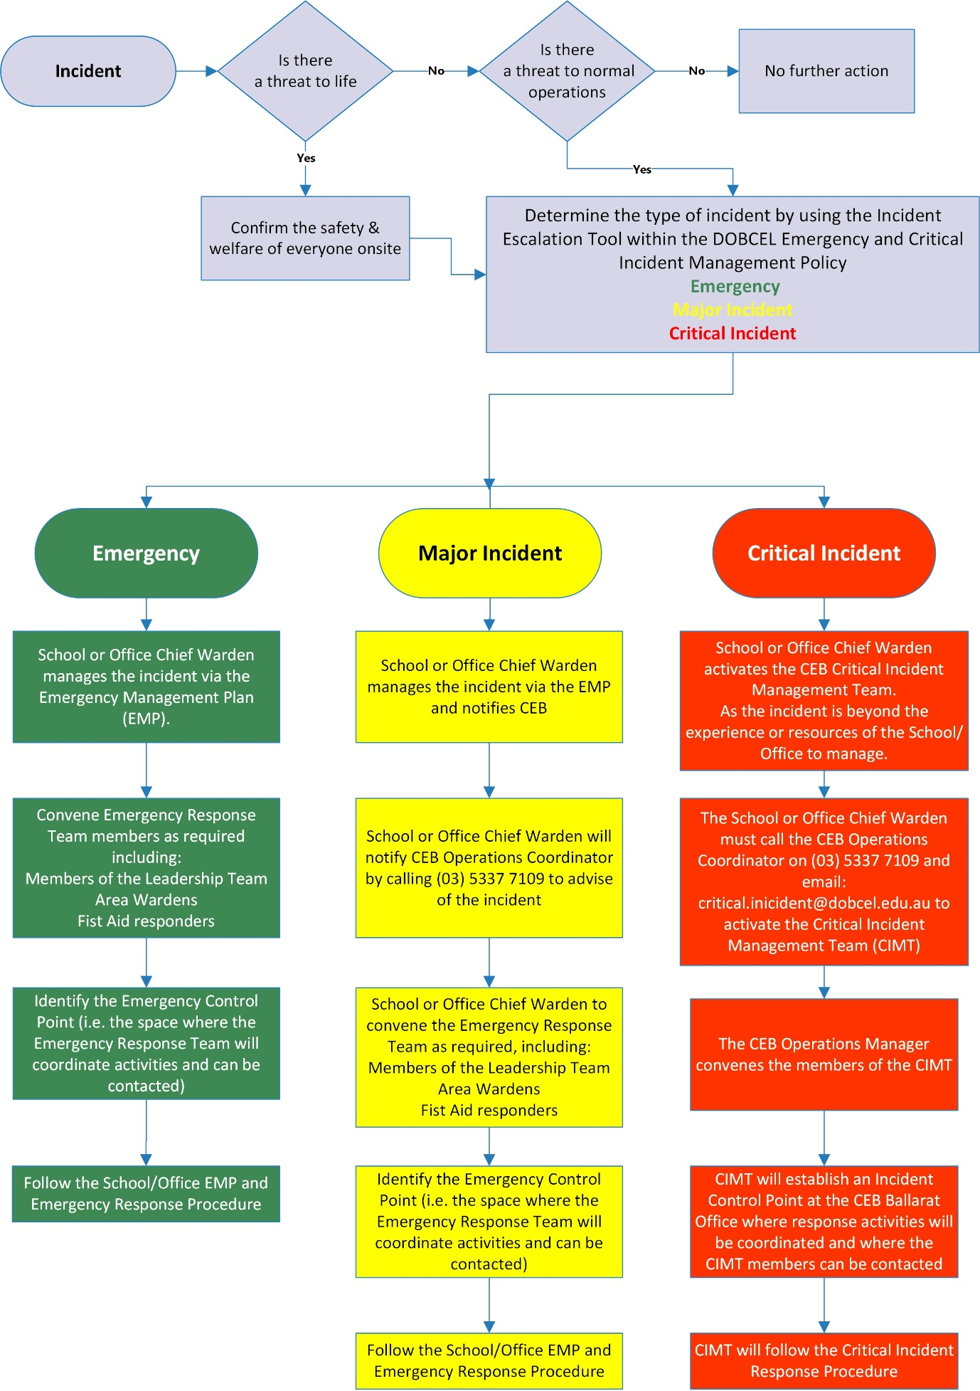

To notify or activate the DOBCEL Critical Incident Management Team call (03) 5337 7109 or
Email: critical.incident@dobcel.edu.au

